**Title**

Kristina V. Akulinina, Alexander V. Kirdyanov, Vladimir V. Kukarskih, Alexey I. Kolmogorov, Viktora V. Agapova, Alberto Arzac

**Abstract**

An increase in temperature in high latitudes will lead to changes in the water balance and thermal regime of permafrost soils, which will affect the structure and functioning of plant communities in northern biogeocenoses. A method for studying the response of plant communities to environmental and climate changes is dendroclimatic analysis of the radial growth of trees. The article presents the results of such an analysis for the trees *Pinus sylvestris, Larix sibirica, Larix gmelinii and Larix cajanderi*, growing in a zone of continuous permafrost in six areas within the Arctic Circle.

A correlation analysis was carried out between tree ring width indices and climate indicators for the period from 1966 to 2021. The results showed that the main factor limiting the radial growth of trees in all study areas is air temperature, mainly in June and July. Sliding correlations showed that in recent decades there has been an increase in the influence of temperature anomalies on tree growth, especially under conditions of increasing average daily temperature. This indicates potential changes in the structure of plant communities and their adaptation to new climatic conditions. It was also noted that an increase in temperature in the summer months leads to a more pronounced positive dynamics of radial growth, which may be associated with improved photosynthetic processes and increased water availability under conditions of permafrost thawing. In conclusion, the results emphasize the importance of further research aimed at assessing long-term changes in northern ecosystems in response to global warming.

**Keywors:** Arctic, climate change, tree growth, tundra,treeline

1. **Introduction**

In the last decade, an unusual phenomenon has been observed in the Arctic region: unprecedented warming in the forest-tundra ecotone. This climate change has a significant impact on the dynamics of biogeocenoses in this region. However, the effects of warming are not limited to changes in plant communities. They also affect deep soil processes, influencing the timing of the formation of the active soil layer in areas of continuous permafrost.

In addition to negative effects, rising temperatures can also create favorable conditions for tree growth. Higher temperatures and earlier access to water due to thawing permafrost can contribute to the flourishing of vegetation in the region. Research (link) confirms that all these factors are already affecting the condition of forests and their components. Such changes can have consequences not only for biodiversity, but also for ecosystems in general.

The width of tree rings is directly related to growth conditions, which depend on temperature, precipitation, and other environmental factors. The aim of the work is to assess the climate response of tree radial growth to changes in temperature, precipitation, active soil depth, snow depth, and wood species.

Studying these changes and their possible consequences is becoming increasingly important in the context of global climate change and anthropogenic activities. In addition, changes in forest-tundra ecosystems can serve as indicators of broader climate trends, making their study key to assessing future change scenarios in Arctic regions.

**2.1 Study area and sampling**

The research was carried out at six localities in a longitudinal transect above the Arctic Circle, from northeastern Finland to northeastern Russia (27°E to 166°E; Fig. 1A). Four main conifer species in the forest-tundra ecotone were sampled (i.e., *Pinus sylvestris*, *Larix sibirica*, *Larix* *gmelinii* and *Larix cajanderi*). Thus, in the westernmost sites, Finland (hereafter FIN) and Apatity in the Kola Peninsula (hereafter APA) - *P. sylvestris*. In the central sites, the Polar Urals (hereafter PUR) - *L. sibirica* and Khatanga (hereafter KHA) - *L.gmelinii*. In the easternmost sites Chokurdakh (hereafter CHO) and Bilibino (hereafter BIL) *L. cajanderi*. The sites are characterized by harsh climatic conditions that significantly affect the growth and development of tree species. Temperature fluctuations, short growing seasons and low precipitation levels create specific conditions. Thus, over the 1966-2021 period, mean annual air temperature ranges from 0,3 °C in APA to -13,1°C in CHO (Fig. 1B), and the annual precipitation totals from 558 mm in the APA to 210 mm in BIL (Fig. 1B). Climate data from the nearest weather station to the sampling sites were obtained from climexp.knmi.nl (Finnish site) and www.meteo.ru (Russian sites).

The average annual temperature trend for each site shows a general increasing trend (Fig. 1C), as do the temperatures of the combined months (June–September) (Fig. 1D). Average number of days per year with temperatures equal to or above 5 °C for the study period 1966–2021 was 133 days and 70 days for the APA and CHO sections, respectively (Table 1). In addition, there is an increase in the number of days with temperatures equal to or above 5 °C at a variable rate from 44 to 52 days per decade at P < 0.01 for the more western and central sites, and 29 days per decade for Chokurdakh and 11 days for Bilibino (P < 0.01) (Supplement, Fig. 1A).

At each site, a minimum of 20 trees were sampled at breast height (1.3 m) with a 5-mm increment borer powered by an electric drill. Tree height and diameter at breast height (dbh) were recorded for the sampled trees (Table 1).

A 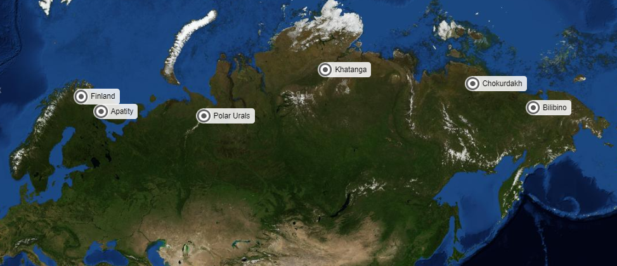

B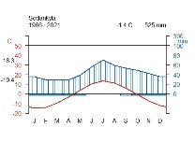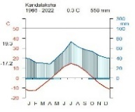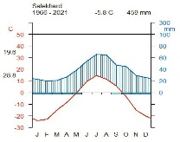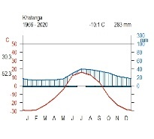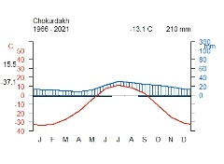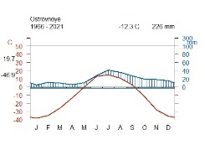

C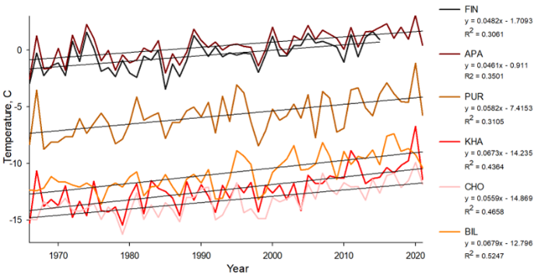 D 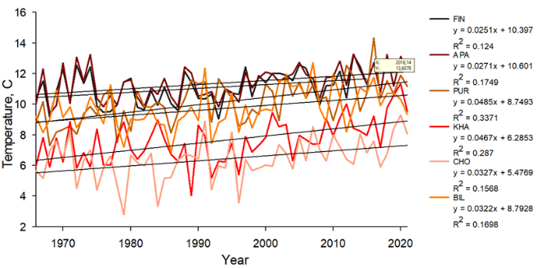

**Figure 1.** Location and climate of the study area: (A) white dots show the location of sampling sites (FIN, Finland, APA, Apatity; PUR, Polar Ural; KHA, Khatanga; CHO, Chokurdakh; BIL, Bilibino). (B) Climate diagram for Sodankyla weather stations, Kandalaksha, Salekhard, Khatanga, Chokurdakh, Ostrovnoye for 1966 – 2021 period. (C) Average annual temperature trends for the periods 1966–2021 in the study areas. (D) Trends in average monthly temperature June-September for the period 1966–2021 in the study areas.

**Table 1** - Characteristics of areas

|  |  |  |  |  |  |  |
| --- | --- | --- | --- | --- | --- | --- |
|  | FIN | APA | PUR | KHA | CHO | BIL |
| Coordinates | 68°77′ N  27°15' E | 67°36' N  33°2' E | 66°54' N  65°45' E | 71°57' N  102°40'E | 70°30' N  147°10' E | 68°02′ N  166°40' E |
| Elevation (masl) | 179 | 127 | 125 | 35 | 7 | 468Начало формы |
| Near weatherstation | Sodankyla  (52 km) | Kandalaksha  (62 km) | Salekhard  (58 km) | Khatanga  (7 km) | Chokurdakh  (2 km) | Ostrovnoye  (48 km) |
| T mean | -0.48 | 0.40 | -5.76 | -12.32 | -13.28 | -10.86 |
| T June-July | 13.09 | 13.05 | 11.90 | 9.43 | 8.31 | 13.05 |
| T June-September | 11.04 | 11.37 | 10.13 | 7.62 | 6.41 | 9.71 |
| P total | 526.56 | 547.48 | 457.21 | 283.10 | 210.40 | 237.10 |
| P June-July | 124.86 | 124.42 | 118.98 | 68.60 | 52.30 | 69.10 |
| P June-September | 235.50 | 242.80 | 229.53 | 141.14 | 104.36 | 131.05 |
| Days  ≥ 5 °C | 121+12,2 | 133+12,2 | 105+13,6 | 82+13,1 | 70+12,7 | 93+11,4 |

**2.2 RW measurements and chronologies construction**

The collected cores were subjected to resin extraction using a Soxhlet apparatus with 96% ethanol for 72 hours. After this, wood cores were fixed on wooden supports and polished with a grinding machine with a grit up to 1000. An Epson Perfection V800 flatbed scanner (Epson, Japan) was used to scan the polished cores. Tree-ring width (RW) was measured using CooRecoder version 9.3 (Cybis Elektronik & Data AB in Sweden). The wood cores were visually cross-dated and its accuracy was statistically checked with COFECHA (Grissino-Mayer 2001). In the ARSTAN program (Cook E.R., Holmes R.1996), standardization (indexing) of the original time series was performed using a negative exponential or linear function to compensate for age-related changes in ring width. Next, a procedure was carried out to remove the autocorrelation component in order to reduce the influence of non-climatic factors and preserve the high-frequency climate response (Cook E.R., Peters K.,1981). To assess the quality of the obtained chronologies, the following statistical parameters were calculated: sensitivity coefficient (msx), inter-series correlation coefficient (Rbar) and expressed population signal (EPS) (Table 2) (Wigley T.M.L., Briffa K.R., Jones P.D. 1984).

Table 2 - Сhronology characteristics for the period 1966–2021

|  |  |  |  |  |  |  |
| --- | --- | --- | --- | --- | --- | --- |
|  | **FIN** | **APA** | **PUR** | **KHA** | **CHO** | **BIL** |
| msx | 0.25 | 0.25 | 0.40 | 0.55 | 0.44 | 0.44 |
| EPS | 0.65 | 0.89 | 0.96 | 0.96 | 0.97 | 0.96 |
| Rbar | 0.48 | 0.40 | 0.63 | 0.68 | 0.64 | 0.69 |

**2.3 Climate-growth analysis**

To assess the relationship between tree radial growth and climate conditions, pairwise correlation analysis was performed using Pearson correlation coefficients. The analysis was performed between standard chronologies and average monthly climate data, including total precipitation and average air temperature.

Tree-ring width showed a positive correlation with summer temperatures (June and July), but the timing and intensity of the climate signal varied between sites. Trees at sites PUR, KHA and BIL showed an earlier response to June temperature (r = 0.54; r = 0.43; r = 0.41, respectively, at P < 0.01), site CH r = 0.24 at P < 0.05, except for the westernmost sites (FIN and APA), where a significant relationship was found only for July temperature (r = 0.35 and 0.41, respectively, at P < 0.01) (Fig. 2A). Temperatures of the previous months, as well as March, had a significant negative effect on the radial growth of trees in the Chokurdakh area (Fig. 2A).

Correlation analysis between residual chronologies and monthly precipitation showed that precipitation affected radial growth only at the local level, without a clear pattern for all the study areas. Summer precipitation did not demonstrate a statistically significant effect on radial growth in the considered areas. The most noticeable positive effect of precipitation was found for the APA area in August (r = -0.39, p < 0.01) and in December of the previous year (r = -0.35, p < 0.01) (Fig. 2B). For the easternmost area (BIL), last year's October precipitation had a positive effect (r = -0.41, p < 0.01) and April precipitation had a negative effect (r = -0.37, p < 0.01) (Fig. 2B). In general, no long-term impact of precipitation on the radial growth of trees was detected in any of the study areas.

А 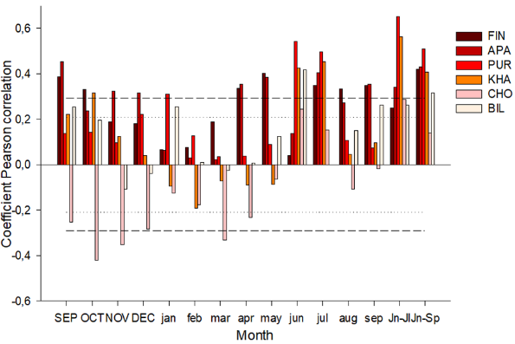B 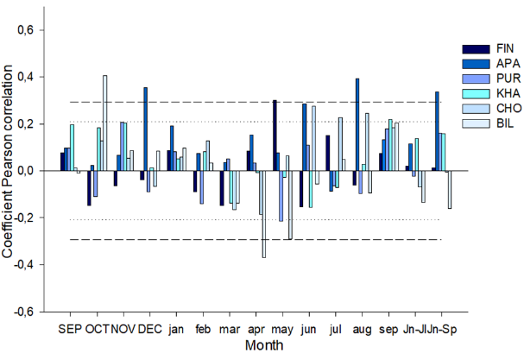

**Figure 2.** Coefficients of paired (A and B) correlations of tree-ring width with temperature and precipitation

Sliding correlations calculated from daily average data also revealed a positive effect of midsummer temperatures (June 22–July 17) at all sites (Fig. 3A). However, when moving from west to east along the northern profile, an increase in maximum correlation coefficients is observed, except for the BIL site, and their shift to earlier dates. There is a gradual decrease in the effect of July temperature and an increase in the effect of June temperature (except for the CHO site) on the variability of tree growth indices. Thus, in the western regions (FIN, APA), the effect of July temperatures is not as significant (DOY 191 and 189; r = 0.31 and 0.42, respectively; p < 0.01) compared to the central sites PUR, KHA (DOY 178-180 and 181; r = 0.60 and 0.61, respectively; p < 0.01) and BIL located to the east (DOY 173 - 175; r = 0.56; p < 0.01). The most intense climatic response was noted at the beginning of July (July 2) at the CHO site (DOY 183; r = 0.67; p < 0.01), but this date is very close to the end of June. No pronounced long-term effect of precipitation on radial increment was found at any of the studied sites (Fig. 3A).

A 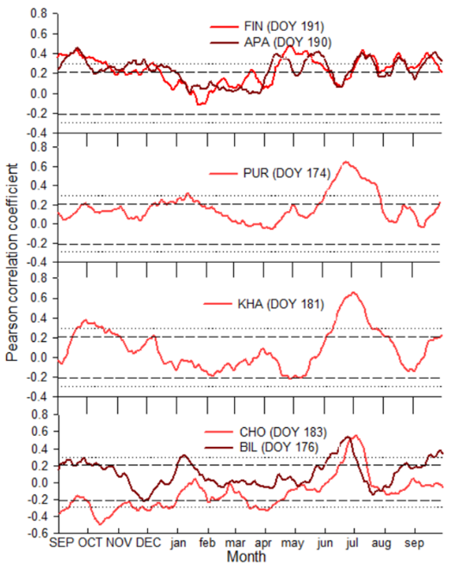 B 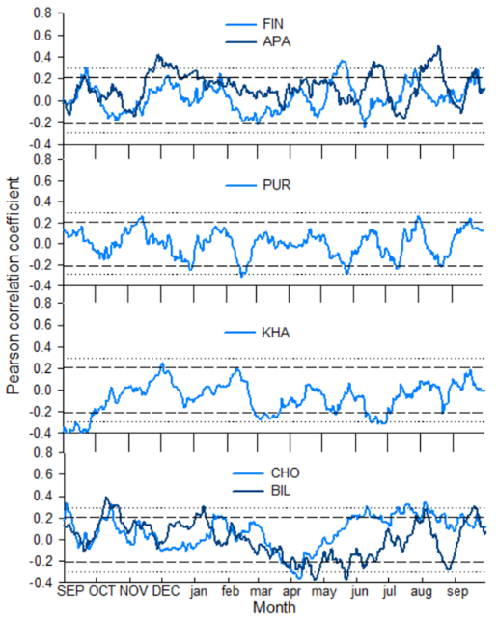

**Figure 3.** Coefficients of sliding correlations (A and B) between residual indices of tree-ring width and climate data (temperature and precipitation)

**Moving correlations**

We used a 25-year sliding window, shifted 1 year at a time, to calculate Pearson correlation coefficients between tree-ring width indices and monthly climate variables (mean temperature and total precipitation) for each study site. Cross-sectional correlation analyzes were performed using the Treeclim package in R. There was a slight effect of precipitation at all sites. The strongest correlations were found between tree ring width and summer temperature. Correlations were examined over the period 1966-2021.

The resulting graphs show sliding correlation coefficients over time: the X-axis represents year, and the Y-axis represents correlation coefficient values. The data show a strong positive correlation between tree ring width and temperature, indicating that higher temperatures are associated with wider tree rings. Correlation coefficient values ​​range from 0,0 to 0,65 indicating a moderate to strong positive correlation.

The plots also show that the correlation between tree-ring width and temperature is not constant over time, with periods of stronger and weaker correlation.

Air temperatures in June-July had a positive effect on TRW in PUR (r=0.__ ; p<0.01, respectively), while FIN and APA showed a positive response only to July temperature (r= 0.__; p<0.01), and BIL - only for the temperature of the month of June (r= 0.__; p<0.01).

Moving correlations indicated a decrease in the sensitivity of TRW to June temperatures for the KHA site and to July temperatures for the CHO site.

The overall influence of average summer temperatures for 2 months (June-July) began to have a significant effect on the FIN, APA and BIL sites since the 1980s. For the PUR and KHA sites, the impact occurred throughout the study period. The combined significant impact of the warm months from June to September can be divided into 2 groups: for some sites, the impact occurred from the beginning of the study period until the 1980s (APA, PUR, KHA, CHO), for other sites, from the 1980s until the end of the study period (FIN, BIL) (Fig. 4A).

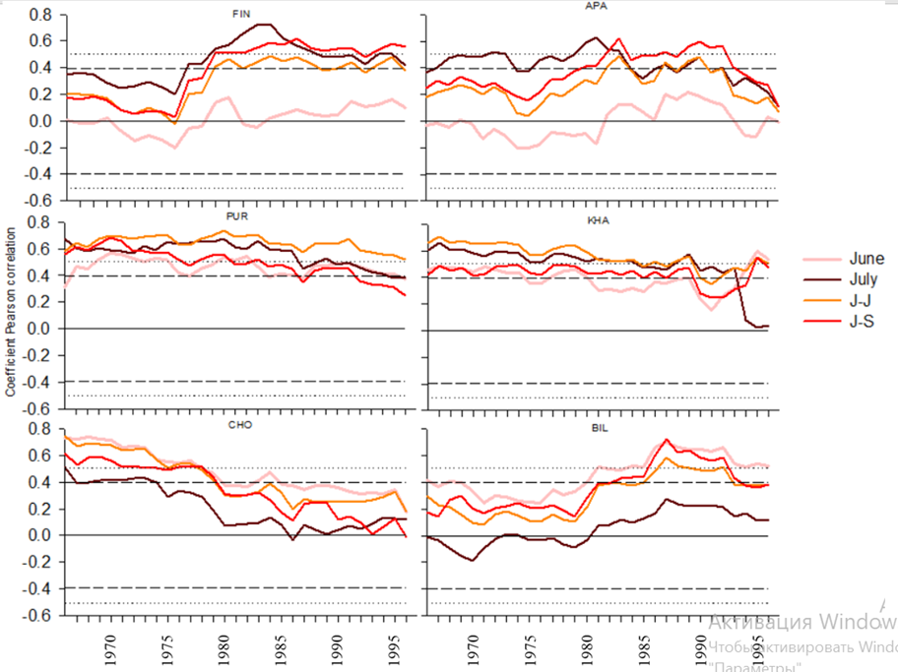

**Figure 4.** Sliding correlations (25-year window with 1-year step) of tree-ring widths with June, July, June-July, June-September temperatures for the total period 1966–2021

**Spatial correlation fields**

Spatial correlation fields confirm the strong influence of mean June–July temperatures on PUR and KHA (r = 0.__ and 0.__ (P < 0.001), respectively). CHO show lower correlations for these months. Correlations of tree-ring width with mean June–September temperatures are high for FIN, APA, PUR, and KHA, reaching r = 0.__, r = 0.__, r = 0.__, and 0.__ (P < 0.001), respectively (Fig. 4A). Correlations with temperatures of the first two summer months are absent in June for FIN and APA sites, and in July for BIL site. June temperatures were moderately correlated with TRW for the CHO and BIL sites (r = 0.001, r = 0.001), respectively (Figure 4A), and July temperatures were moderately correlated with FIN and APA (r = 0.001, r = 0.001), respectively (Figure 4A).

|  |  |  |  |  |
| --- | --- | --- | --- | --- |
|  | JUN | JUL | JUN- JUL | JUN-SEP |
| FIN |  |  |  |  |
| APA |  |  |  |  |
| PUR |  |  |  |  |
| KHA |  |  |  |  |
| CHO |  |  |  |  |
| BIL |  |  |  |  |



**Figure 5.** Spatial field correlations between June, July, June–July and June–September mean temperatures (Berkeley 1°) and tree-ring widths for the period 1966–2001. Black dots indicate the locations of sampling sites.

???

Correlation analysis between residual chronologies showed significant values ​​for the areas FIN and APA (r = ), where it grows *Pinus sylvestris*, and for the areas CHO and BIL (r = ), where it grows *Larix cajanderi.* For other areas (PUR, KHA), where the main species are *Larix sibirica* and *Larix gmelinii*, no significant values ​​were found.

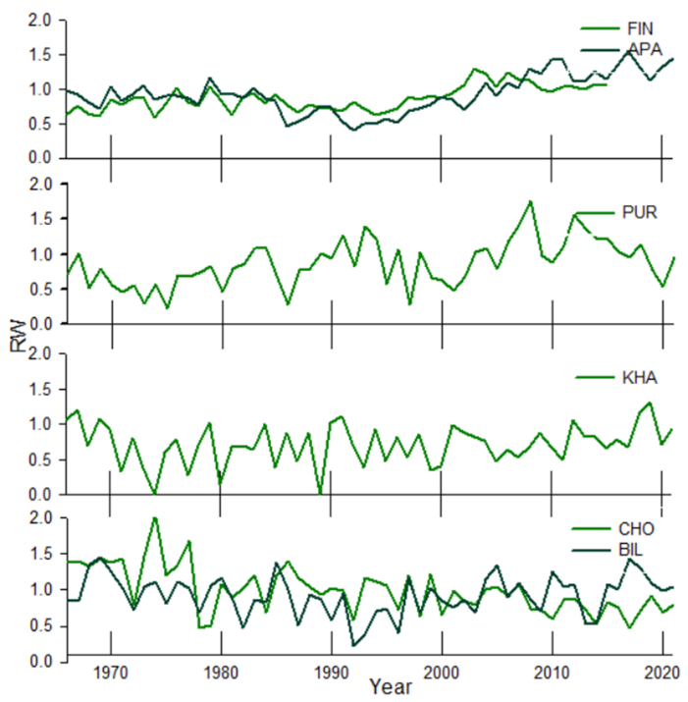 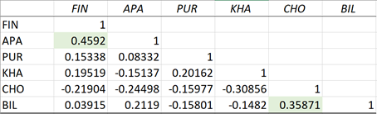

???

Active soil layer and Snow depth

The Arctic Circle extends from Finland and the Kola Peninsula in the west to Chukotka and the Russian Far East in the east. It is a vast region with a strong influence of permafrost. However, the type and extent of permafrost vary depending on climate and geography, from isolated patches of frozen soil to widespread permafrost of 100 to 500 m. The depth of permafrost increases as you move east, causing significant changes in ecosystems. In the west, the soil freezes less and the vegetation includes mixed forests. While in the east, the climate becomes harsher and the soil freezes to a greater depth, limiting vegetation to tundra ecosystems.The depth of the active layer of the earth, as a rule, increases from west to east in the northern latitudes of Eurasia, which is associated with changes in climate and soil and plant conditions in this direction. In the west, the climate is milder and more humid, which limits the freezing of the ground. As you move east, the climate becomes more continental, with harsher winters. In Siberia and the Far East, winter lasts longer and is much colder, which contributes to deeper freezing of the ground and an increase in the active layer. Also, in the western regions, where snow falls gradually, the snow cover remains stable, creating a heat-insulating layer. In the east, in the continental climate of Siberia, snow falls in shorter periods and is sometimes less dense, which contributes to increased freezing of the ground, especially with strong winds that blow away the snow and reduce its insulating properties.

Soil types also vary by area. In regions with a milder climate, podzolic and peat soils predominate, which can support the growth of coniferous trees. In more eastern regions, permafrost, gley, and peat types predominate. The soils are poorer, which significantly reduces the ability of plants to grow.

Snow depth

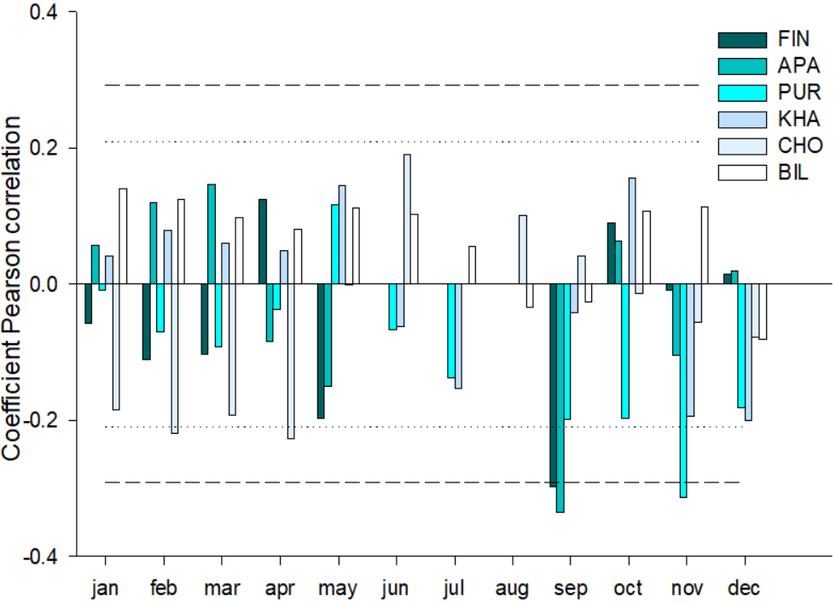

**Discussion**

Our results show that the growth of parent rocks growing in the permafrost zone of northern Russia is mainly influenced by temperature.

Winter temperatures are still quite low, but the amplitude of temperature fluctuations is decreasing. Changes are also observed in the winter months, which leads to a gradual softening of winter temperatures. Temperatures in the summer period are gradually increasing, which significantly affects the duration and nature of the melting of ice and snow cover. Winters are becoming less extreme, although cold winters still remain part of the climate picture. This affects environmental and natural processes, especially the melting of permafrost.

The longitudinal patterns revealed for each of the sites in the response of tree growth indices to changes in thermal conditions of the summer months can be explained as follows. It is known that when moving from west to east, the continentality of the climate increases, i.e. the temperature of the coldest winter month decreases, the amount of precipitation decreases, and the thickness of the snow cover decreases (Borisov, 1967; Parmuzin, 1979). In addition to the decrease in precipitation from west to east, there are differences in their distribution by month. In Western Siberia, the main amount of precipitation falls in the second half of summer and in autumn. In the most continental areas, the maximum precipitation occurs in the summer, mainly in July-August, while their monthly amount is insignificant (up to 40-50 mm). In July, when air temperatures are highest, the upper soil horizons dry out significantly, and the main limiting factor is the lack of moisture. As a result, the tree stops radial growth long before the end of the vegetation period (Vaganov, Shiyatov, Mazepa, 1966).

Since the warm period of the year at the northern limit of tree growth is extremely short, the timing of the onset of vegetation, i.e. the transition of daily temperatures through 5 °C, is of primary importance for the tree growth cycle. The vegetation period in the eastern regions of the Siberian Subarctic begins earlier than in the western regions. In connection with this, the contribution of June temperatures to the variability of tree growth increases for eastern areas and July temperatures for western regions (Vaganov, Shiyatov, Mazepa, 1966).

There is a widespread opinion that during the vegetation period there can be no moisture deficit in the active soil layer, since it constantly comes from the thawed layers (Parmuzin, 1979). However, detailed observations of the seasonal moisture balance in permafrost soils refute this (Pozdnyakov, 1986). The moisture balance in the active layer is formed by moisture in the thawed layer, precipitation, and the influx of water from the lower, deeper layers as they thaw. But the moisture level in these layers depends on how moistened they were in the fall, before the soil froze, and this reserve is not always sufficient to compensate for the deficit that occurs if evaporation exceeds the moisture influx in the current season. The depth of the active layer reaches its maximum by the end of the season, when the main growth processes in trees slow down or stop.

Приложение  
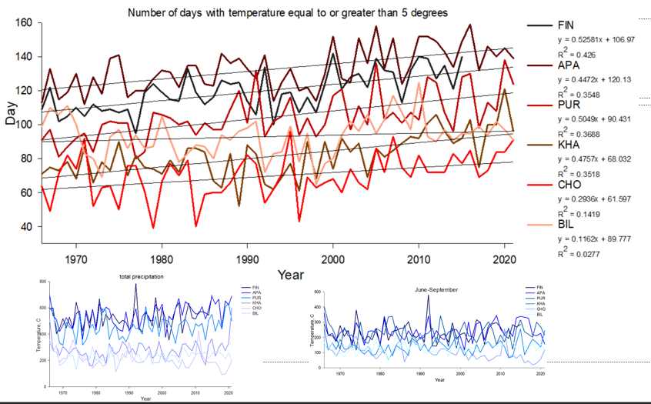

|  |  |  |  |  |  |  |
| --- | --- | --- | --- | --- | --- | --- |
|  | **FIN** | **APA** | **PUR** | **KHA** | **CHO** | **BIL** |
| Coordinates | 68°77′ N  27°15' E | 67°36' N  33°2' E | 66°54' N  65°45' E | 71°57' N  102°40' E | 70°30' N  147°10' E | 68°02′ N  166°40' E |
| Elevation (masl) | 179 | 127 | 125 | 35 | 7 | 468Начало формы |
| Near weatherstation | Sodankyla  (52 km) | Kandalaksha  (62 km) | Salekhard  (58 km) | Khatanga  (7 km) | Chokurdakh  (2 km) | Ostrovnoye  (48 km) |
| Number of trees | 35 | 18 | 26 | 18 | 20 | 20 |
| Average age of trees (years) | 162 ±59,4 | 263 ±73,6 | 133±35,9 | 300±36,7 | 331,35±118 | 163±22 |
| Mean dbh (cm) |  | 36.6 | 15.3 | 22.3 | 13.7 | 16.9 |
| Mean tree height (m) |  | 14.5 | 9 | 11.7 | 5.4 | 9.12 |
| Average tree ring width (mm) | 0,98+0,12 | 0,98+0,14 | 0,95+0,3 | 0,95+0,29 | 0,98+0,29 | 0,98+0,11 |
| Average number of days per year with temperature  ≥ 5 °C | 121+12,2 | 133+12,2 | 105+13,6 | 82+13,1 | 70+12,7 | 93+11,4 |
| Active soil layer deep (cm) | ? | ? | ? |  | 14 | ? |
| msx | 0.25 | 0.25 | 0.40 | 0.55 | 0.44 | 0.44 |
| EPS | 0.65 | 0.89 | 0.96 | 0.96 | 0.97 | 0.96 |
| Rbar | 0.48 | 0.40 | 0.63 | 0.68 | 0.64 | 0.69 |